Summer-Mae Wall
LL-000023418
Occupational Specialism

Evaluation of Greenfield Local Hub (GLH)

Contents
Table of Contents
Evaluation of Greenfield Local Hub (GLH) 1
Contents 1
User acceptance Criteria 1
Functional and Non-Functional Requirements 3
Functional Requirements (Business Needs) 3
Non-Functional Requirements (How the system should do things) 6
Key Performance Indicators (KPI) 7
How well the solution works 8
The effectiveness of the assets and content used 8
How well goals were met 9
Functional Requirements 10
Non-Functional Requirements 10
User Acceptance Criteria 10
Key Performance Indicators 12
How the project went 13
What went well? 13
What went wrong? 13
If I Were to Start Again what would I change? 14
Before the exam 14
During the exam 14
How the prototype could be developed further 14
Based off user feedback 14
Personal opinions 15
Based off Task 2 evaluation 15
Evaluation of Future Development From TASK 2 15
Product categories and search bar 15
User and Staff Settings 15
Password validation 16
Finished Staff System 16
Proper system testing 16

User acceptance Criteria
no. | Criteria | How generated | Why important
1.1  1.2  1.3  1.4  1.5  1.6  1.7  1.8  1.9  2.1  2.2  2.3  2.4  2.5 | Clear navigation bar  Be able to see what products are available and see their ingredients  clear instructions on each page  fast loading times (2-5 seconds max)  alter orders  view orders  be able to select a delivery date and time  clearly see costs  be able to contact customer support easily  automated orders  product organisation  make staff accounts  limit what staff accounts can access  view orders to deliver/ collect | Research through alternative systems (see 12)  restaurant empathy maps (see 6)  following law (see 11) and alternative system research (see 12)  Research through alternative systems (see 12), NFR (see 9)  user stories (see 7)  user groups (see 5)  user stories (see 7)  Research through alternative systems (see 12)  user stories (see 7)  user stories (see 7), empathy maps (see 6)  user stories (see 7), Research through alternative systems (see 12)  user stories (see 7)  user stories (see 7)  empathy maps (see 6), user stories (see 7) | It is important so that users can easily understand and navigate the site.  To check allergens in products, following legislation on food regulations (see 1)  to make it easy for users to understand and reduce stress when using the system  fast loading times are needed to retain customer attention and to ensure the website looks professional  customers may change their mind on what they need to purchase and will want to have the ability to alter their order before it is delivered.  Users need to be able to see what they have ordered and ordered in the past so they can keep track of spending, what works for them, what doesn’t etc.  users need to be able to select a time that works for them for food to be delivered so that they can be there when it arrives.  Users need to be able to see how much products cost so that they can plan and buy products that match their budget  Users need to be able to contact customer support to report any issues they may have. Customers like good customer support that isn’t frustrating to work with.  Users may want the same food delivered on a set schedule (eg businesses). Automated repeat ordering can make this easier on them so they don’t have to waste time placing orders every time.  Products need to be organised in a meaningful way so that users can find them and know what they are purchasing.  Admin staff need to be the only accounts able to make staff accounts so that the system can’t be infiltrated and for UAC 2.4  staff should only be allowed to see data related to complete their jobs in line with GDPR (see 11) to protect the data of users.  It is also important to limit access to reduce confusion when using the staff system  staff need to be able to see who ordered what to package and deliver orders to the correct customer.

Functional and Non-Functional Requirements

Functional Requirements (Business Needs)
1. Customer Needs

no. | Criteria | How generated | Why important
1.1  1.2  1.3  1.4  1.5  1.6 | Users should be able to register and login to the system securely  Users need to be able place an order  Users need to be able to alter and delete orders  Users should be able to view their orders  users should be able to log out of their account  users should be able to view their account details | KPI’s (see 10), risks (see 13)  empathy maps (see 6)  User acceptance criteria (see 8)  user stories (see 7)  Decomposition (see 14)  law/ legislation/ guidelines (see 11) | To prove an increase in account creation (KPI 1.2, see 10), users need to be able to securely make and login to accounts. It needs to be secure to ensure that accounts are not intercepted or created by bots to prevent Denial of service (DOS) attacks.  Users need to be able to place an order for a product for the system to work effectively and sell products.  Users need to be able to add or remove items from their order before it ships out to fit their needs. (families/ households may change their mind on what they want to order)  Users should be able to view their order and its details so that they know what they have ordered and where/ when its coming to check all the information is correct and to verify the order has been placed successfully.  Users need to be able to log out of their account so that forms aren’t resubmitted (causing data to be duplicated in the database) and so accounts are kept secure.  Users need to be able to see their account details so they can be kept up to date. Ensuring the data isn’t redundant/ useless is important for security (passwords etc). It also helps ensure that the system is adhering to GDPR/ DPA 2018 (see 11).

2. Staff Needs

no. | Criteria | How generated | Why important
2.1  2.2  2.3  2.4 | Staff need to be able to login to the system securely  Admin staff need to be able to create accounts and set permissions  Staff need to be able to view orders  Staff need to be able to view and update stock | Risks (see 13)  laws (see 11), risks (see 13), User Stories (see 7)  empathy maps (see 6), risks (see 13), law (see 11)  empathy maps (see 6), risks (see 13), law (see 11) | Users need to be able to securely make and login to accounts. It needs to be secure to ensure that accounts are not intercepted and use to access data on customers (eg address) for malicious purposes.  Only admin staff being able to create staff accounts prevents random people signing up to the staff system and ensures that permissions are correctly set to fit the employees role so that they can only access what they need to for their job (e.g only accessing necessary data on customers to complete work)  Staff need to be able to view orders so that they can be packed correctly. Only staff members in charge of packing orders should be able to see the contents.  Staff in charge of keeping stock need to be able to see what they have received and update the system accordingly so that users can purchase it. Only users who should be updating stock should be able to, to prevent malicious misuse of the system so that the system is secure.

3. General Needs

no. | Criteria | How generated | Why important
3.1  3.2 | The website needs to be accessible and easy to navigate  The system needs to display information about each product clearly | Law (see 11), KPI 1.5 (see 10)  law (see 11), food standards (see 1), User stories (see 7) | The system needs to be accessible to all users under the equality act (see 11). It is best done by following WCAG guidelines to ensure that all users are considered. It is also important to retain customers as they will not become frustrated with the system and are more likely to choose it again.  The system needs to clearly state what a product is and its ingredients so customers are properly informed on what they are buying (protecting their right under the consumer rights act (see 11)), ensuring all products information and standards are up to date with food standards (see 1) and so customers are kept happy because they have received what they wanted when ordering.

Non-Functional Requirements (How the system should do things)
1. User Needs

no. | Criteria | How generated | Why important
1.1  1.2 | System needs to be easy to use  system should be able to run on a portable device | Research through alternative systems (see 12)  empathy maps (see 6) | The system needs to be understandable and easy to use so users choose it over alternative providers  system needs to be able to run on portable devices for staff who are delivering products (remote access) and users who are using the system on a portable device (ordering via a phone) as is the current norm

2. General Needs

no. | Criteria | How generated | Why important
2.1  2.2  2.3  2.4 | Passwords need to be hashed using sha256  Pages need to load in 2-5 seconds max  system should be adaptive to change.  system should have proper encryption when transporting data | Risks (see 13)  Research through alternative systems (see 12), UAC (see 8)  laws/ legislation/ guidelines (see 11), risks (see 13)  laws/ legislation/ guidelines (see 11), risks (see 13) | Passwords need to be hashed with an up to date hashing method (sha256) so that passwords are stored securely in the database  Pages need need to load in a timely matter to retain customer attention and ensure the website looks professional.  The system needs to be adaptable to changes in legislation and to meet the clients needs in the future. The system not being upgradeable makes it less efficient and unsuitable for long term usage.  The system needs to be secure, especially when handling data as per GDPR and to sustain trust with customers that their information is being stored securely.

Key Performance Indicators (KPI)

no. | Criteria | How generated | Why important
1.1  1.2  1.3  1.4  1.5  1.6  1.7  1.8 | Rise in sales  Increased User Account creation  increased orders  increased customer referrals  increased amount of repeat visitors/ customers  less security issues/breaches  increase in staff morale  loyalty rewards being claimed and used | Reviewing sales data  checking audit logs, seeing more accounts being added  reviewing sales data, checking audit logs, stock decreasing at a faster rate  referral programs, KPI 1.2  audit logs, KPI 1.3  risks (see 13)  staff feedback, amount of work done, staff retention  reviewing loyalty scheme data, user stories (see 7) | Seeing a rise in sales is crucial in rating the success of a new system because it shows that it is profitable.  An increase in account creation shows interest and use in the system by the consumer.  An increase in orders means an increase in sales, which proves that the system is profitable  customers referring each other to use the system proves that it is easy to use and like by consumers  customers returning to view and order more products. Shows trust and loyalty with the company and system being built.  Shows the system is up to date and secure to reduce the chances of a breach into the system. Keeping data secure as GDPR states (see 11)  staff’s happiness is crucial to a business. Happy staff work more efficiently and quickly to a high quality.  It also improves staff retention as unhappy staff leave to work elsewhere.  People claiming their loyalty rewards proves that they are using the system and are ordering repeatedly. This shows the system keeps customers engaged and loyal to the service.

How well the solution works
The solution meets the requirements set out from Greenfield Local Hub. The system allows users to register and login to the system, add items to basket, view their basket to update the quantities of items, checkout and cancel their order. With a loyalty scheme that adds points when an account is made and based on how much a user spends when ordering on the system. This meets Greenfield Local Hubs requirements for what they needed for a customer system.
I also began development on a staff system allowing staff accounts to be created by admins, update the quantity of products etc.

The effectiveness of the assets and content used
In my design and prototype, I chose to use lorem ipsum for any text. I chose to do this as it replicates what would be done in a real development environment.
Realistically, a client would need to provide the content themselves and it would not be written by the development team (unless paid for) as the developers will not be educated enough on the topic to give true, valuable information.
In the case that a client does not have content prepared for the prototype is is usual to use lorem ipsum to simulate how text would look. This also ensures that the content gets updated before deployment as it is very clear where lorem ipsum is to change compared to other choices
An option I could of used was to use AI to generate temporary filler information to populate my webpages. I chose against this as AI is known to make things up and I wouldn’t want to spread any misinformation.
It would also be a concern that the text wouldn’t be properly reviewed or changed before deployment leaving the website unfinished, with false information polluting it.

For images on the website, I chose to use stock images to be placeholders for real imagery on the website. I chose to use these as again, in a real development environment it would be the clients responsibility to provide images and content to use. Stock images allows for Greenfield Local Hub to make the proper choices on whether they wish to obtain the rights to use any imagery or replace it with their own.
The alternative I had was using AI to generate imagery to use on the website. I chose against this for two reasons.
You cannot copyright AI imagery as it is not human made and users tend to respond poorly to AI imagery.
Users may purposely choose an alternative if companies use AI to generate their photos as it makes the page and products they are selling look fake and not genuine. There is a public destain for AI usage by large companies as it removes jobs from artisans and tends to have mistakes and not look appealing to people. Another reason is the rise in AI generated scam products, I thought it was Appropriate to choose against AI imagery to make the products look more real.

With the feedback I collected, the sources for the research were students, family and friends. This means the feedback groups for both technical and non-technical feedback were not the ideal testers to use but due to the limitations of the exam and connections I currently have. It is all that was available. In a real development environment, I would of chose to use users more likely to use the system (home makers, more women etc) to see what they would like to see and what would make the system outshine the competition.
Due to this, the data collected may not be the most reliable sources of information but still have meaning in how the system can be improved.

How well goals were met
Most of the goals I had set out during development were met, I properly planned out each version of my development to ensure that all the requirements were met to an acceptable quality. (see example below)
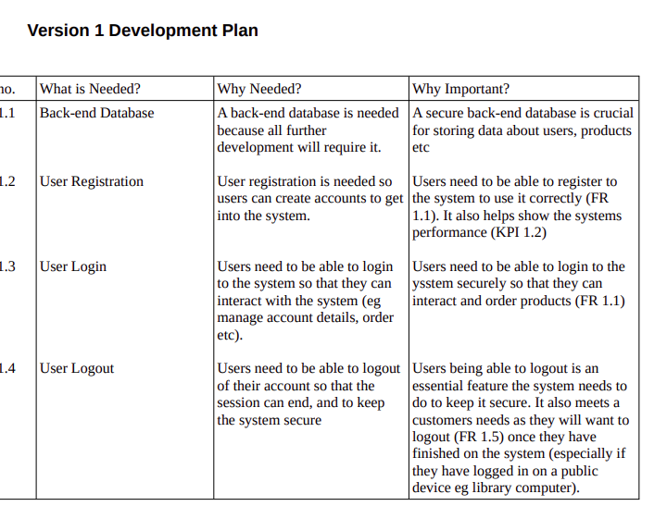
I properly organised how I would approach building up the system, the basics of what is needed, why it is needed and why it important to the system. I successfully related reasoning back to my (FR, NFR, UAC and KPI’s) to ensure that the system met the requirements I had set during the proposal of the project. (please see those above for review)

Functional Requirements
I managed to be able to meet a large amount of the requirements but not all of them. I Managed to accomplish the basic functionality (login and out, register, place order, cancel orders) but failed to add any of the additional requirements I had made (eg 1.3. Users cannot alter their orders)
Enough of the functional requirements were met to make a usable prototype but ones that aren’t met would help develop the prototype into a more fleshed out system with more functionality to meet users needs.
I also believe the website is not accessible enough to users based of the feedback gathered in task 3a. Users found the website confusing and often were lost when exploring the webpage and required some guidance.

Non-Functional Requirements
The system failed to meet 1.2 due to the constraints of the exam as the system could not be tested on a portable device. I also failed to add that functionality to the CSS because of this. This could be further developed in the future.
The system also failed to meet 2.4 also due to the constraints of the exam development environment.
The system met all of the other requirements, I had no issues from users during feedback about how fast the page loads (2.2). It loads almost instantly and the passwords are hashed properly in the database for user and staff accounts (2.1).

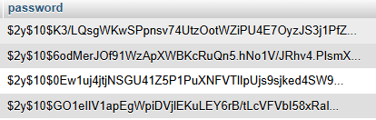

I tried to make the system adaptable to change (2.3) by leaving sections that can be done in the staff system. The CSS and content are also very basic, leaving room for improvement by someone more highly skilled at CSS and web design.

User Acceptance Criteria
I met some of the more basic requirements I had set out (eg 1.1, 1.2, 2.3, 2.4, 1.8, etc) but failed to meet others. As seen below, the system has a clear navigation bar, allows users to view product details, order products, view their orders. Etc. I feel that I managed to meet all the requirements within the scope of the project.

Ones I failed to meet (1.5, 1.3, 1.9, 2.1, 2.2, 2.5) are due to a lack of experience coding these specific projects. I also feel like some I had reached too far beyond my reach as to what I would possibly complete within the 30 hour development.

1.1 – I added a navigation bar, which helped users navigate the site. The section I feel I failed with is the basket icon. It is not very clear as to where or what it is and could of used it being separated or some text to make it more clear and accessible to users.
1.2 – Users can click on a product to view more details about it, including the farm it is from, stock available, a description etc.
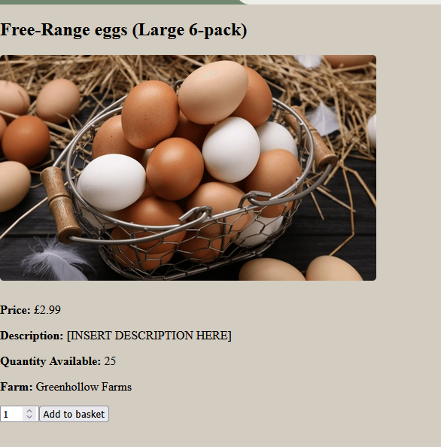

1.3 – I failed to meet this requirement as users tended to be lost when navigating the site.

Users had no issues with 1.4 as the page loaded quickly and did not leave users waiting.

I also failed to meet 1.5 due to my inexperience coding e-commerce sites and only previously working on booking sites.

Key Performance Indicators
A lot of my KPI’s could not be proven in the exam conditions due to it not being deployed. However during the feedback task asking users how likely they would be to refer family and friends to use the system (1.4). Unfortunately, the ratings averaged out to 4.09. This proves that users are not likely to recommend the system to family and friends. This is most likely due to a lack of styling on the website making it hard for users to navigate around the system
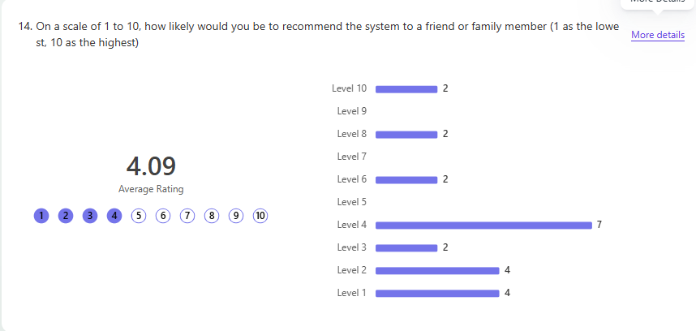
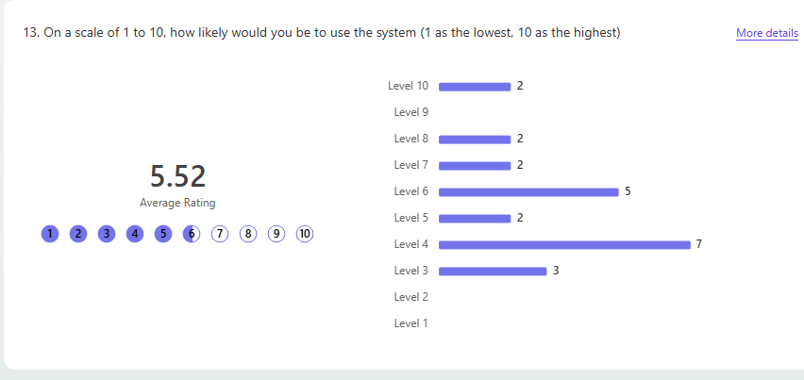
During this task I also asked users how likely they were to use the system (1.5). This also had a low ranking at an average of only 5.52. This is most likely due to the 404 error and lack of content on the system. Due to the low ranking, I also feel like I failed to successfully meet this requirement.

How the project went

What went well?
During my project, I thought the design and the functionality of my prototype were my strongest parts of the system.
I am very proud of how my individual product page functions (allowing users to click on a product and view more details based on the product id) as it was my first time developing something like that and it fits in with the system so flawlessly.
I am also proud for the basket system as earlier in the year I had only practised basic booking systems as the e-commerce scenario has not been seen before (based on revision of past papers).

I spend a lot of time perfecting my design skills over the year and during my work experience as I did so in a web development company. I made sure I understood the tool I used to make my webpage designs and that they looked professional and as actual viable sites.

What went wrong?
Many things went wrong during the development of my system. I felt I failed at developing the styling (CSS) of the website, I missed some simple mistakes due to a lack of testing, I failed to manage my time to make sure I had enough time to build up my staff system (leaving it unfinished) and I fell that I failed to make an enjoyable feedback form for users and to meaningfully analyse the data.
I also feel like I failed to express my thoughts during the evaluation and feedback task. Towards the end of the exam I felt a bit burnt out and should’ve taken more steps to ensure that I had proper time to rest and not burn myself out towards the end, leaving my work of lesser quality then what I could produce if I had taken better care of my mental health.

If I Were to Start Again what would I change?

Before the exam
If I were to start the year again, I wish I would’ve tried harder to be on time for college and used my time more meaningfully when it came to revision. I wish I had built up more experience with CSS and gathering feedback rather then wasting it. I should’ve learnt better testing strategies and prepared myself better for the exams.
I wish I had spent more time improving my writing skills along side with my coding skills as they have worsened in quality, leaving me with a lower vocabulary and failing to properly express my opinions in write ups.
I also wished I had built up some higher confidence of myself and my abilities so that I didn’t feel so behind and out of place in class. Being one of 2 female students in my class, I often felt a lot dumber and lesser then my male counterparts. They were all so much more confident about what they could do and I never did anything like that. I just let myself worry and burn out. With all these confidence problems I had, I should’ve used the resources I had available for support to help me through burnout and to make me feel more confident about the work I’ve done during my time at college.

During the exam
During the exam, I wish I had spent more time on testing my prototype rather then adding more features, I missed a very basic mistake that led to a 404 errors when users were testing the system due to my lack of meaningful testing.
I didn’t record enough of my tests and did not perform enough for the system to liable to usage.

I also got very lazy during the feedback task and did not sufficiently justify the questions I added to my feedback form not properly analyse the data afterwards.
Users found the form long and boring (especially in the technical feedback). This limited the feedback I was able to gather as I couldn’t get as much as I had hoped as the form took too much time to complete. Some of the questions did not return enough data to be worth answering.
I would’ve also taken more time for myself outside of exam hours and tried to keep more positive about what I made and tried to evaluate myself better.
I wish I had planned my evaluation and feedback tasks to better to have a higher understanding of what I needed to accomplish in those tasks.

How the prototype could be developed further
Due to the scope of my project, I missed out on some crucial features (eg encrypting data, leaving the database connections in plain text). These would be some of the first things I would further develop to be more secure to protect data and prevent breaches into the system.

Based off user feedback
Based off of user feedback from task 3a, I would work on improving the CSS of the system, More further testing to ensure that silly mistakes aren’t left in the code and I would make the system more secure (as mentioned above).
These faults made the system harder for users to navigate (eg the basket being really small and hard to find) and frustrated users.

Personal opinions
Something I failed to mention is the lack of a payment system. A payment system would be a crucial addition to the system as it is needed for the site to be profitable and work correctly as well as give the loyalty scheme points meaning. Currently, all the loyalty scheme is adding and removing points where as with a payment system it could be fully developed to help users save money and return as customers.

Based off Task 2 evaluation
At the end of task 2, I wrote an evaluation of future development, explaining future plans for the system. I will be adding that evaluation in below as I feel that what I wrote there is still meaningful after task 3a. See below:

Evaluation of Future Development From TASK 2
If I were to develop this project further, I would implement and update some of the following features.

Product categories and search bar
As mentioned in my Overall evaluation, I would implement product categories that would allow a user to browse products based on the category so they can fully see what products there are to offer and they don’t have to see the products they don’t want too (eg if someone who doesn’t eat meat or fish do not like to look at it, they wouldn’t have too).
I would also implement a search bar so users can search for specific products which can help them find them a lot faster then if they were to search through the categories. This would help improve staff efficiency on the staff side and reduce customers becoming frustrated when they can’t find products they want to buy.
It would make the customer and staff system easier to use as well as look and feel much more professional.

User and Staff Settings
I would also implement Proper account settings for users and staff allowing them to properly manage their accounts to meet their needs.
Customers
Customers would have more freedom over their accounts. Having full control to change their email or password, to request and view data stored about them in the database (required under the data protection act) and the ability to delete their account if they choose too.

Staff
Staff would need to have their account settings managed by admin staff with them having to talk to staff about password changes, account removal (if they leave the company etc)

Password validation
The register system for all users does not contain any proper form of password validation beyond confirming it is correct. This means that users can make their password anything they want, with whatever characters they want. This can leave a large amount of user accounts susceptible to being hacked and taken over as passwords will be easy to guess.
Proper password validation would prevent this by ensuring that users have a special character, number, capital letter etc to make their passwords harder to guess.

Finished Staff System
The staff system is not finished. I did not have time to add the ability for staff to view orders for packing or delivery.
I would ensure that staff can see order contents (baskets) and whether an order is for collection or delivery so that when they are packed they can be organised into the correct categories. (ensuring that a collection delivery isn’t accidentality sent to delivery and vice versa. It would be important that staff cannot see a users details for just packing an order.
Staff should only be able to see customer details during delivery (addresses) or for collection (confirming that they hand the order to the right person) so this would be handled separately from what staff can see whilst packing orders to protect customers data.

Proper system testing
I would ensure that proper testing of the system occurred. Testing different browsers. 2 or more users ordering at the same time (eg if someone orders the last product whilst its in someone’s basket) and ensuring that the system is secure and cannot be breached or manipulated to do something it is not designed for.

